* [Find the upward recommendation chain for member ID 27](https://pgexercises.com/questions/recursive/getupward.html)

with recursive recommenders(recommender) as (

select recommendedby from cd.members where memid = 27

union all

select mems.recommendedby

from recommenders recs

inner join cd.members mems

on mems.memid = recs.recommender

)

select recs.recommender, mems.firstname, mems.surname

from recommenders recs

inner join cd.members mems

on recs.recommender = mems.memid

order by memid desc;

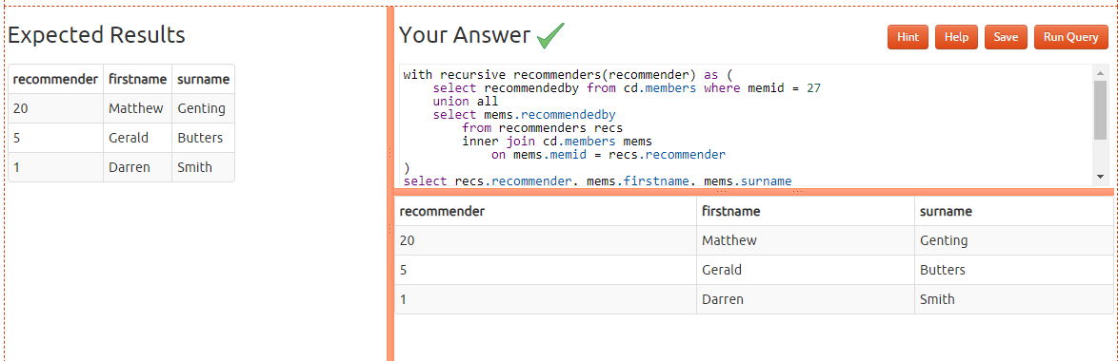

* [Find the downward recommendation chain for member ID 1](https://pgexercises.com/questions/recursive/getdownward.html)

**with recursive recommendeds(memid) as (**

**select memid from cd.members where recommendedby = 1**

**union all**

**select mems.memid**

**from recommendeds recs**

**inner join cd.members mems**

**on mems.recommendedby = recs.memid**

**)**

**select recs.memid, mems.firstname, mems.surname**

**from recommendeds recs**

**inner join cd.members mems**

**on recs.memid = mems.memid**

**order by memid**

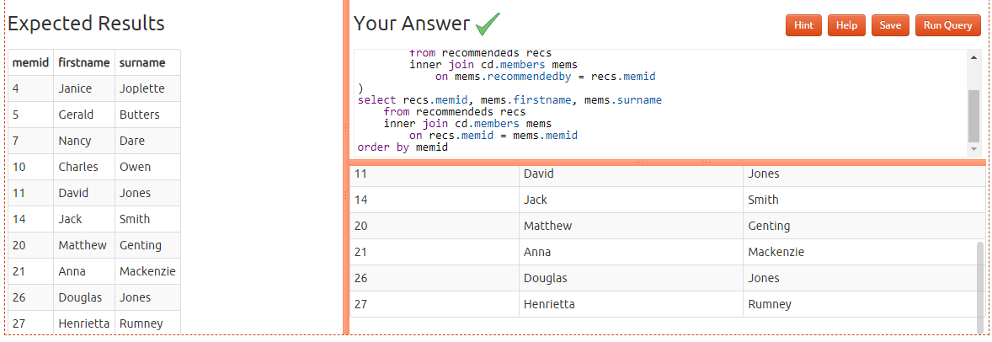

* [Produce a CTE that can return the upward recommendation chain for any member](https://pgexercises.com/questions/recursive/getupwardall.html)

with recursive recommenders(recommender, member) as (

select recommendedby, memid

from cd.members

union all

select mems.recommendedby, recs.member

from recommenders recs

inner join cd.members mems

on mems.memid = recs.recommender

)

select recs.member member, recs.recommender, mems.firstname, mems.surname

from recommenders recs

inner join cd.members mems

on recs.recommender = mems.memid

where recs.member = 22 or recs.member = 12

order by recs.member asc, recs.recommender desc;

